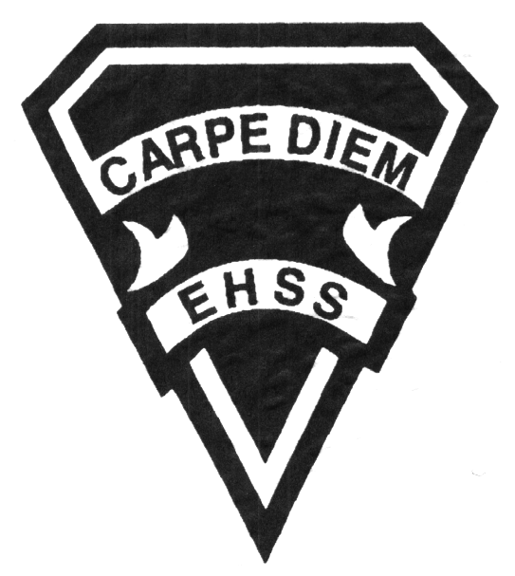

**2019/2020**

### The West and the World

**Social Sciences Department**

## Earl Haig

SecondarySchool

# **CHY4U**

**Evaluation Profile & Outline**

**Course Description/Rationale/Overview:** This course investigates the major trends in Western civilization and world history from the sixteenth century to the present. Students will learn about the interaction between the emerging West and other regions of the world and about the development of modern social, political, and economic systems. The skills and knowledge developed in this course will enable students to understand and appreciate both the character of historical change and the historical roots of contemporary issues.

**Class Requirements:** Students should have materials specified by the subject teacher at the beginning of the year.

The textbook for this course is The West and the World. Students will be issued this book at the beginning of the course. The replacement cost for this textbook $ 115.00.

**Assessment and Evaluation Strategies**

Students will also be expected to complete assessment activities of a formative nature in order to learn and to practice the specific expectations that will compose the summative evaluations. Examples of formative assessment may include homework checks, quizzes, peer assessment, presentations, reflection writing, role-play scenarios and observation.

Each unit or strand of the course will be evaluated using summative evaluations. Examples of summative evaluations are tests, case studies, interviews, reports, presentations, seminars, debates, research and other writing assignments.

**Late and/or Missed Evaluation**

##### Late Assignments*

For each assignment, the teacher will inform students of the due date. The teacher may decide to create an ultimate deadline. If an assignment *is submitted after the deadline, the teacher may deduct marks up to and including the full value of the assignment*

.

**Missed Tests**

It is the student’s responsibility to make arrangements, ahead of time, for any tests/quizzes that are missed. If a student misses a test/quiz for an unforeseen reason such as illness, the student must bring a note signed by a parent or guardian**. Alternatively a medical certificate may be requested by the teacher.** The student must be prepared to write the test/quiz immediately upon return to school at a time determined by the teacher. Once the tests/quizzes have been evaluated and returned, students will not be able to make up a missed test - a mark of zero will be assigned.

**Subject-Specific/Department Information**

Teachers in the Social Sciences Department can be reached at (416) 395-3210, ext. 20075 or 20085. Parents wishing to meet with a teacher are requested to make an appointment with the teacher prior to coming to the school.

**Learning Skills\***

**Responsibility** – meets deadlines; takes responsibility for own behaviour

**Organization** – establishes priorities and manages time; uses information, technology and resources top complete tasks time management

**Independent Work** – follows instruction with minimal supervision; uses class time appropriately to complete tasks

**Collaboration** – accepts an equitable share of work in a group; builds healthy peer relationships; works with others to achieve group goals

**Initiative** – looks for opportunities for learning; demonstrates curiosity; approaches new tasks with a positive attitude

**Self-regulation** – sets own goals and monitors own progress; seeks assistance with needed; makes an effort with responding to challenges

###### Final Mark

The final mark for this course will be determined based upon an accumulation of marks from unit summative activities and from a final summative evaluation

**Year’s Work 70%**

This is a culmination of evaluations that have been completed throughout the year. It may include tests, presentations, research, or topic specific assignments.

**Final Summative Evaluation 30%**

This summative activity for this course will comprise of a comprehensive final exam based on key concepts and themes presented during the course.

**Achievement Categories and Weighting**

* **Knowledge / Understanding – 20%**

Knowledge of facts and terms; understanding of concepts, principles, guidelines and strategies; understanding of relationships among concepts.

* **Application – 30%**

Synthesizing knowledge and understanding into new and familiar contexts as well as making connections between various contexts.

* **Thinking Inquiry – 35%**

Formulating questions; planning, selecting strategies and resources; analyzing and interpreting information, and forming conclusions.

* **Communication – 15%**

Communication of information and ideas, communication for different audiences, use of various forms of communication.

*From: Ontario Ministry of Education. *Growing Success: Assessment, Evaluation, and Reporting in Ontario Schools*. Toronto: Ministry of Education, 2010, 11.



**2019/2020**

##### The West and the World

**Social Sciences Department**

## Earl Haig

SecondarySchool

# **CHY4U**

**Evaluation Profile & Outline**

**Course Outline:**

###### Unit 1: Foundations and Institutions Challenged, 1500-1715

Students will learn about the origins of the Western world in Europe by investigating the Renaissance, Reformation, religious wars and nation building to the end of the reign of the great “Sun King”. Students will be introduced to the process of historical inquiry, analysis, and interpretation to begin to understand the “study” of history.

## **Unit 2: Revolution and Change, 1715-1815**

In this unit students will explore the sweeping changes that effected Europe in this century. The Scientific Revolution that pre-dates this era but leads directly into the Enlightenment, the French Revolution and the Napoleon Era will all be closely examined to explore these topics that greatly influenced the rise of modern Europe.

## **Unit 3: A Century of Transitions, 1815-1914**

This unit looks at the massive changes caused by the Industrial Revolution, the forces of conservatism lead by Metternich, which would come into conflict with the growing forces of liberalism and nationalism. The great rise of wealth and power would lead to the “Proud Tower” of Europe c.1900. The European imperialism that resulted and the response to these western ambitions will also be examined.

**Unit 4: The Darkness of the Early 20th Century, 1914-1945**

Students will examine this important watershed era of the Great War and its effect to separate the Victorian world and our modern world. The rise and growth of communism and fascism will be closely studied to understand better the resulting Cold War. An important part of this unit will be a further in-depth analysis of the actual study of history.